**Forex Banking Process for Internet Banking – AS-IS Process**

1. Go to shared folder : Booking Sheet/ Year/Month
2. Pick up previous days workbook- Integrated_BIR_Sheet_Booking_DDMMYYY in deals folder
3. In FX rates worksheet, user copies the rates in column F-I and replaced in column A-D

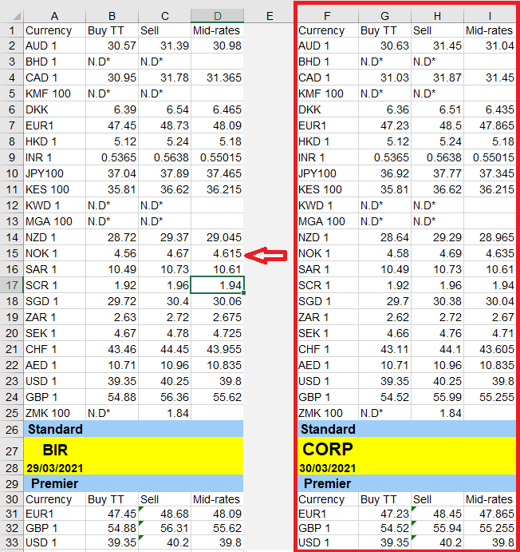

1. Treasury sends indicative rates to users by email.
2. Copy the columns D, E, H and K: Buying, Selling and PAR Rates columns from Indicative Rates worksheet (as given below) and paste in FX Rates worksheet in workbook Integrated_BIR_Sheet_Booking_DDMMYYY to replace the current rates in columns F – I.

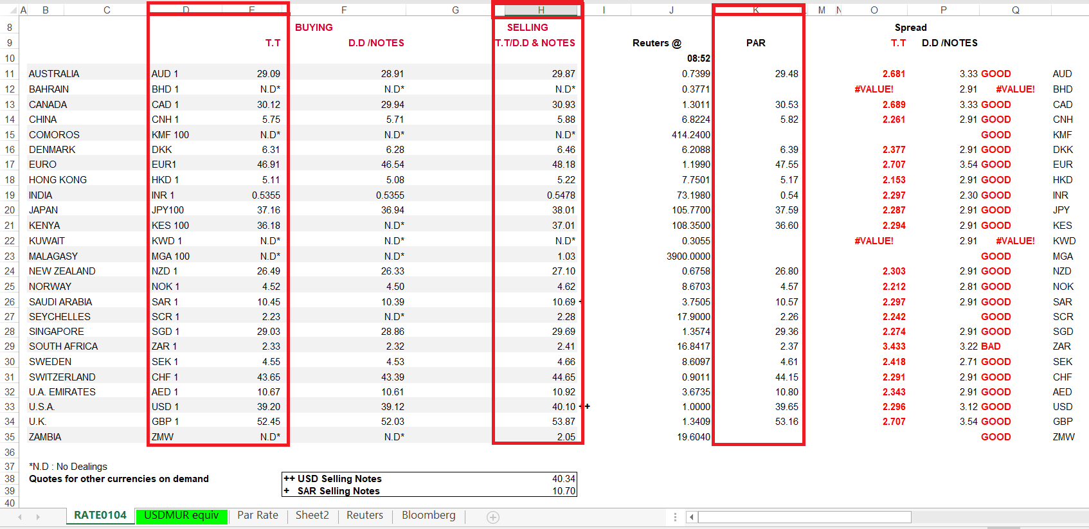

**Note:** 1) Remove China from the list of Indicative Rates

2) Remove the Headers

1. In worksheet T-1 copy all the data from the Rating worksheet and Clear all the data in Ratings Worksheet except the headers
2. In worksheet eBoxExtracts clear contents from column A-CP
3. In worksheet Relevant delete all the data.
4. In worksheet Results clear all filters
5. In worksheet comparison pull the formulas till the end
6. User login to Ebox
7. Go to transaction search for ECH for previous transaction dates. See screenshot below

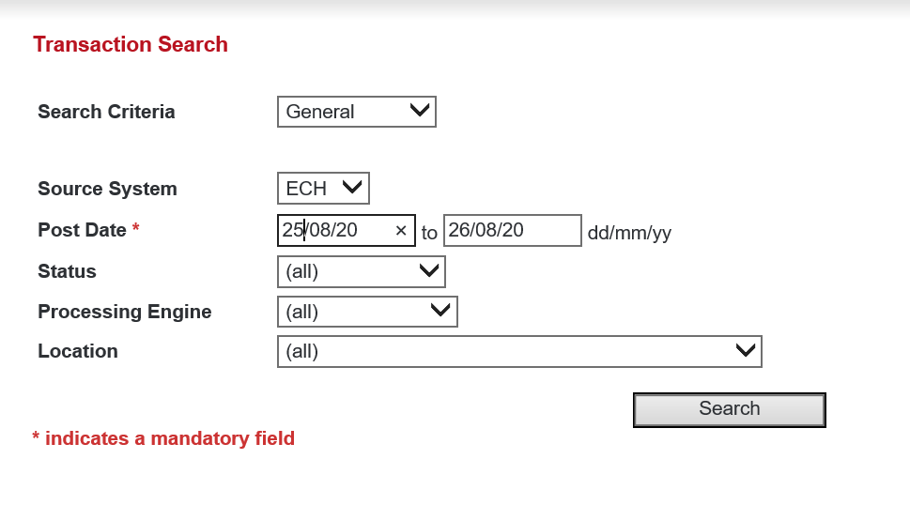

1. After filling the Transaction search requirements as per the screenshot above, User click on search and export the report to an excel file
2. In the exported report from eBox, copy columns A to CP and paste it in Worksheet eBoxExtracts in workbook Integrator_BIR_Sheet_Booking_DDMMYYY
3. In worksheet eBoxExtracts, filter column CQ and remove ‘invalid’
4. Go to worksheet Ratings, copy all the data and paste in worksheet Relevant
5. In worksheet Relavant, filter the column DealID and select only blanks
6. Copy all the blanks and paste in worksheet Ratings

**Exception:** If column status in Worksheet eBoxExtracts is ‘BOOKED’, don’t add the ratings

1. Go to ebox- Transaction search and search for BIR

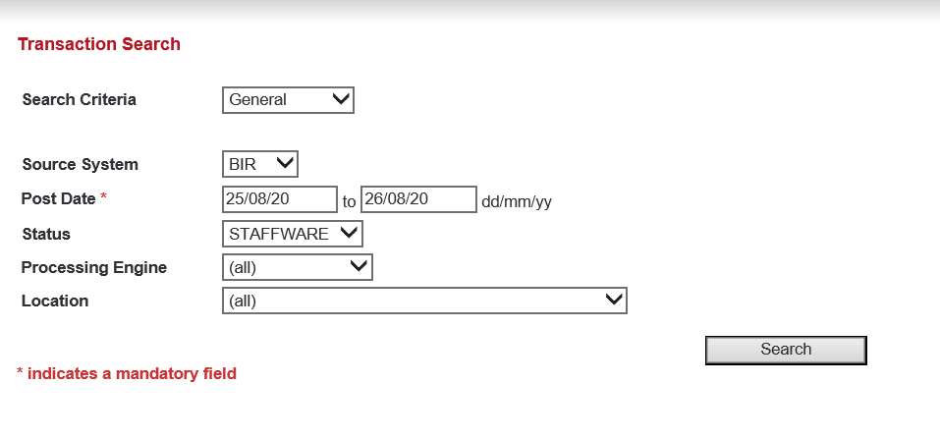

1. Export the report to an excel file as per screenshot below

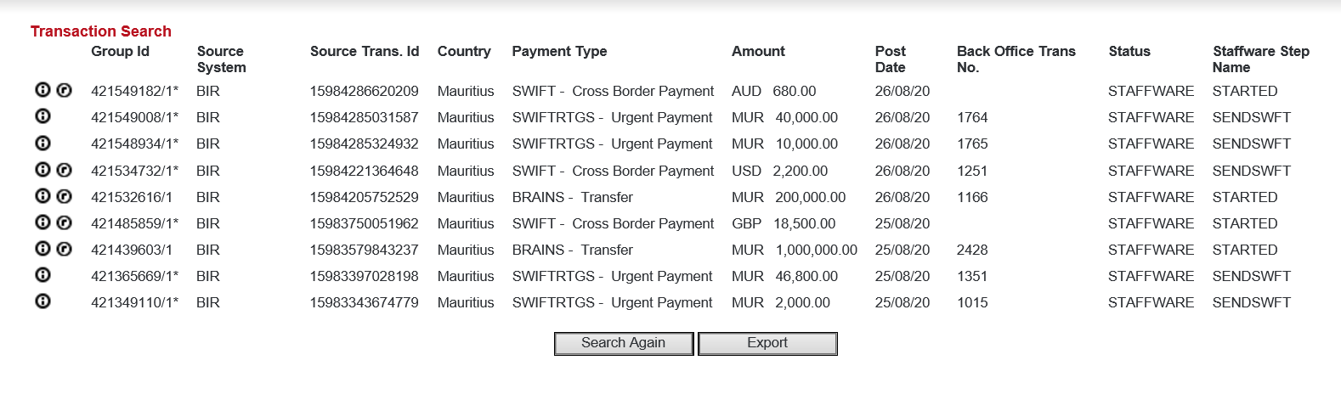

1. Go to worksheet eBoxExtracts in workbook Integrator_BIR Sheet_Booking_DDMMYYYY

1. Copy columns A-CP from the downloaded ebox extract to worksheet eBoxExtracts in workbook Integrator_BIR Sheet_Booking_DDMMYYYY
2. In worksheet eBoxExtracts, Filter the column CQ and remove ‘invalid’
3. Go to Worksheet Relevant and paste the data
4. Sort the data by Originator Currency
5. In worksheet Results, filter column dealID and remove status indicating ‘BOOKED’
6. In worksheet Rating for BIR , make a total of IN and OUT separately.

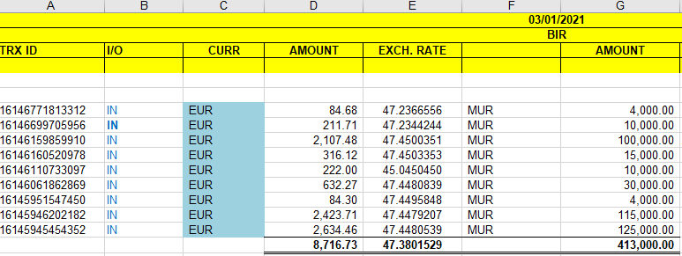

**Exception:** If amount for IN is > MUR 200,000- Entry should be sent to RM for Booking.

Login on eBox to check RM name

For amount < MUR 200,000, calculate the exchange rate by dividing MUR Amount by FGN amount

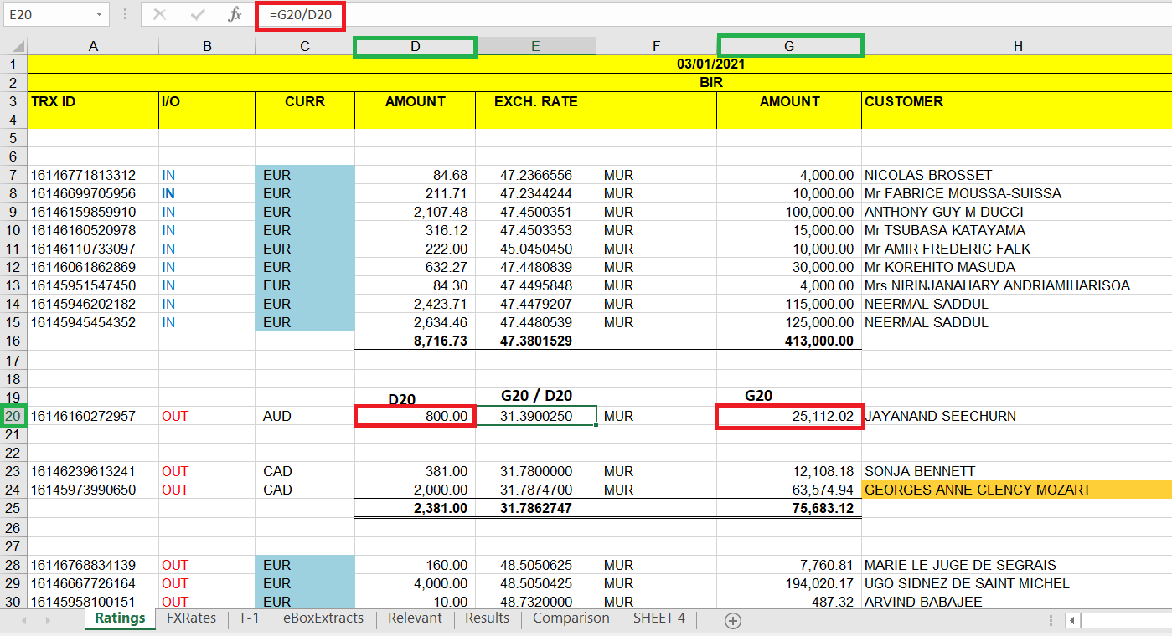

**Exception:** If amount for OUT is > MUR 200,000- copy all MUR amount and change the format as per IN format

If amount is < MUR 200,000, calculate the exchange rate by dividing MUR Amount to FGN amount

1. After dividing the MUR Amount to FGN Amount, sort and group by currency and make totals per currency
2. Login to eBox to check cross currency

**Exception:** if there is cross currency, check for duplication

1. Send email to Treasury for booking at EOD

**1.** Steps to treat Invalid Transactions:

• After copying exported report in worksheet eboxExtract of file Integrator_BIR_Sheet_Booking_DDMMYYY, filter column CQ by “INVALID” and copy all row data to a new sheet

• Filter the data as follows: - Currency (Column AI) <> Currency (Column P) **AND** Currency <> “MUR” (It is a Cross Check, also known as Cross Rate)

- Deal Id (or Deal Ref) is blank or is equal to 0.

• From the filtered rows, get the Source Id

• Go to Mailbox <ABMUMarketSales@absa.africa> and search for mails by Source Id.

• If no mail is found, send a mail for Booking to Market mailbox

Mail Recipient: ABMUMarketSales@absa.africa

Mail CC: ABMU-Treasury-Operations@absa.africa, ABMU

Dear team,

Please book below transactions:

1. **Counterparty** against **Originator <Originator Currency> *<Originator TransactionAmount (Column Q)>*** against ***<Counterparty Currency (Column AI)>***

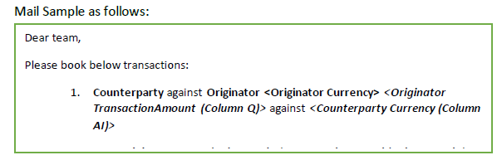

**2.** Market Segment Verification

This verification will be added if amount IN **IS GREATER OR EQUAL TO** MUR 200,000 and after checking the RM Name from eBox. Steps as follows:

* • After opening the Source Id (Trx Id) and after retrieving the RM Name, get the Market Segment from the same window:



* If Market Segment is not equal to 30-CIB, 40-SME, 45-SME and 50-SME, proceed to send mail to RM

Append the row data from Excel for the given Source If in the mail body

*List of RM with corresponding email address should be provided

* • Else if Market Segment is equal to 30-CIB, 40-SME,45-SME or 50-SME, proceed to send mail to Market for booking with Refer Stream in copy.

Append the row data from Excel for the given Source If in the mail body

**3.** Check BAPS Trx

For BAPS, mails are received at 1.59AM and 15.29 PM.

* • Retrieve mails for BAPS which are received at 00:01 and 15:29 for the current date.

Mail Subject: MU Half Hourly Channel Report

The two reports (MU half hourly and MU half hourly IFT) need to be compared and duplicates removed (transactions for the previous day 00:01 – 15:29) and deals reference verified (if there is a deal ref, then record should not be considered)

* • Get the file <NEW BOOKING SHEET Template file> from the shared drive and make a copy for the current date
* • Copy data from Column A-Z from mail attachment file and paste in NEW Booking Sheet template file
* • Filter out all Invalid (Column AA)
* • Perform same steps in Step 1 above (Steps to treat Invalid Transactions)
* • Copy remaining data to sheet Relevant. A formula present in the file will automatically copy the data from sheet Relevant to sheet Results
* • Go to sheet Results and copy the required data to Booking sheet based on the conditions below: - Deal Id should be blank or equal to 0
* - Currency should equal to MUR
* - Sort by “Payment Completed” Status for consideration
* • Booking sheet is stored in shared drive. Bot should send completion mail to User.